## Note: This Doc contains the screenshot of the project which is successfully completed.

# Task 1: Create a windows instance using AMI : Windows 2012 R2 base

# &

# Task 2: Launch the Windows instance using RDP

# 

# Task 3:Install IIS web server using Powershell ISE

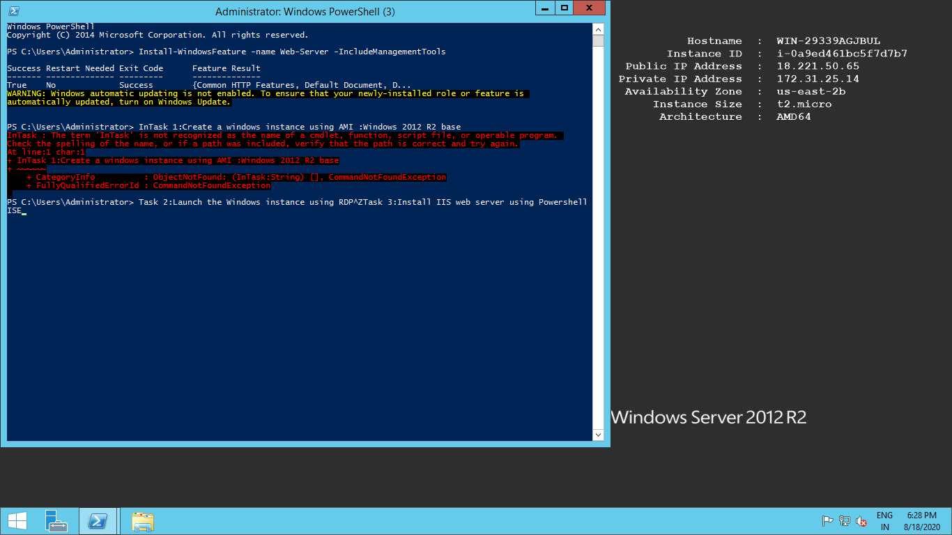

# Task 4: Verify successful installation of IIS Web Server

